

**The Commandery Cafe**

**Catering Concession**

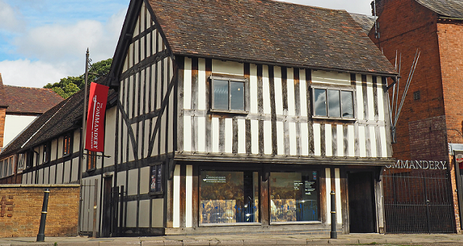

**The Commandery**

Museums Worcestershire (a partnership between Worcester City and Worcestershire County Council) is inviting proposals at this stage, for a catering concession at the Commandery Café, based in the Commandery, Sidbury, Worcester to run from February to December each year, with an option to open in January.

The Commandery is a beautiful Grade 1 listed building, a few minutes’ walk from Worcester Cathedral and the City Centre, attracting around 18,000 visitors a year. It has a rich and varied history, most well-known for its role in the Battle of Worcester when it was the Royalist Headquarters. Today the museum includes an interactive exhibition telling Worcester's Civil War Story.

Embedded in Worcester's unique heritage and a key part of its tourist offer The Commandery welcomes local, regional and national audiences and the Café is an essential part of the visitor experience. We are looking for a Caterer who shares our aim to create a quality experience for all our visitors and encourages them to make repeat visits.

The Commandery is situated next to Fort Royal Park and the busy Birmingham to Worcester canal, attracting walkers, cyclists, boaters and those taking the scenic route into the city.

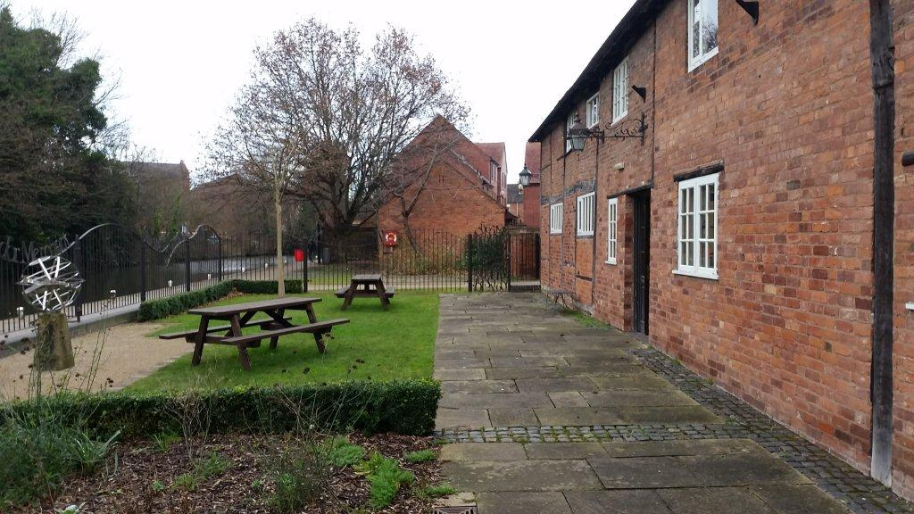

The Commandery welcomes school and group bookings. It is a wedding venue and host to many outdoor and indoor events every year, including theatre in the gardens, living history weekends, children's activities, and other popular events.

The Commandery is also at the heart of the local community and Caterers would want to have a good understanding of its customer base and be willing to contribute to The Commandery’s ethos of being a welcoming and inclusive space.

**The Café**

The Café occupies two rooms on the ground floor of the Commandery, along the canal side of the building and has seating capacity for up to 20 covers inside and additional seating outside within an enclosed grassed and paved area with views over the canal. The Licensee may provide their own additional tables and chairs.

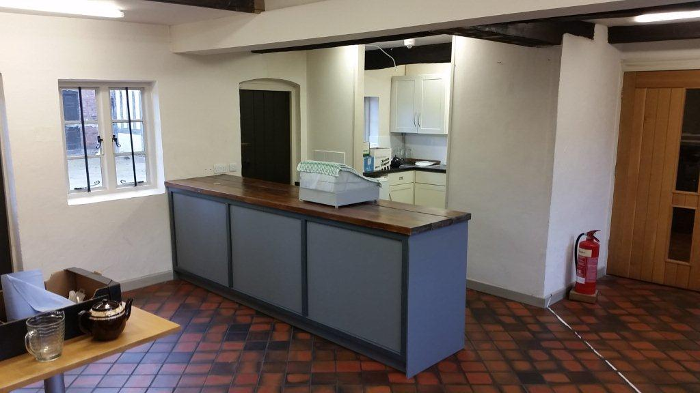

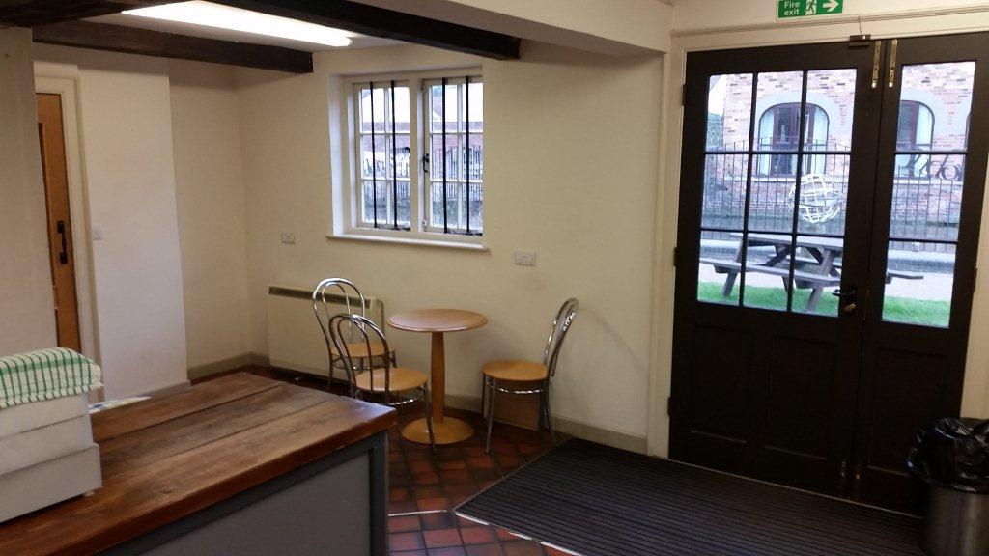

The Café includes a kitchenette area with work surfaces and cupboards.

**Growing the business**

We are keen to support a growing business and the Café may be used outside of normal opening hours for additional catering functions and events, provided any additional use is previously approved by the Museums Manager and subject to payment of an additional fee. The catering concession would also be given first option on providing catering services for Commandery events and initiatives.

Please note the Caterer does not have to pay business rates.

**Proposals**

The concession will be subject to a Licence Agreement for a period of five years (with an option to break after one year) with an option to renew subject to a review of the licence fee and any amendments considered appropriate by the Museums Manager.

Interested parties are invited to submit proposals for the operation of the Commandery Café for a 5 year licence term. The preferred offer is a percentage of gross turnover which should increase over the 5 years as you successfully build the business.

The Caterer should provide ideas for running the catering concession, including type of food and drink to be provided (the range of food and drinks provided will be agreed with the Museums Audiences Manager), opening times, staffing, ideas for additional functions or services to improve the visitor facilities and to grow the business, and an indication of prices. We are also looking for details of experience and how the Cafe may be promoted. Please see Caterers Questionnaire.

Museums Worcestershire (a partnership between Worcester City and Worcestershire County Councils) does not undertake to accept the highest or any offer received, and the additional information requested will be considered as part of the Caterer's submission.

Please send your offer form, names and addresses for trade and bank referees, and completed caterers questionnaire to the **Museums Audiences Manager at The Commandery, Sidbury, Worcester WR1 2HU**, or email: [Helen.Large@worcester.gov.uk](mailto:Helen.Large@worcester.gov.uk) by **4pm on Friday 20th August, 2021**. Interviews will be held at The Commandery the following week and you will be notified as soon as possible.

Further information may be obtained from:

Museums Audiences Manager

Email: [Helen.Large@worcester.gov.uk](mailto:Helen.Large@worcester.gov.uk)

Museums Manager

Email: Philippa.Tinsley@worcester.gov.uk

cid:3384943374_1132425

**Principle terms for a Licence for the catering concession at**

**The Commandery Café**

1. For the purpose of this concession, the Caterer will have the exclusive use of the café and kitchenette together with the use of toilets in common with the museum visitors.
2. The opening hours of The Commandery are:

|  |  |
| --- | --- |
| Monday  Tuesday  Wednesday  Thursday  Friday  Saturday  Sunday | Closed  10am – 5pm  10am – 5pm  10am – 5pm  10am – 5pm  10am – 5pm  11am – 3pm |

***Please note that The Commandery is usually open on Bank Holidays and we would expect the Café to be open on those days. The Commandery is closed throughout January but Caterers may have the option to open the Commandery Café in agreement with the Museums Manager.***

1. Opening during Museum hours is essential, there will also be opportunities outside of these hours at special events and functions. The Licensor shall always have the right to cancel the provision of these facilities on any day or days on giving 48 hours previous notice but assures the Caterer that any such cancellation will only happen in exceptional circumstances. This will also include some Bank Holidays, when the building may be closed.
2. The Caterer will be required to liaise with Museum staff in promoting the venue and providing a catering service which compliments and supports The Commandery’s brand and its events and activities.
3. The equipment listed in the attached schedule is the property of the Licensor and shall be made available for use by the Caterer, should it be required. The Licensor will be responsible for the maintenance and repair of the equipment set out in part 1 (save for damage caused by the caterer and the Caterer will be responsible for all losses and breakages of the equipment in part 2.
4. The Caterer will be responsible for payment of all electricity charges for the concession.
5. The Caterer will be responsible for maintaining all areas in a clean and hygienic condition and will be required to comply with all relevant legislation relating to Health and Safety and food Hygiene with a Food Hygiene rating of 4 or higher. A No Smoking policy operates in this building and surrounding grounds.
6. The Caterer shall comply with the Licensor’s polices on health and safety in the workplace, COSHH and Fire Safety regulations.
7. The Caterer will be required to obtain and retain a minimum public liability insurance of £5 million for the catering concession.
8. The Caterer is responsible for providing their own trade bins and arranging the waste collection. Location of storage of waste bins will be provided by the Licensor.
9. The Caterer will be responsible for the cleaning of the toilet facilities made available to the Caterers for use out of museum opening hours.
10. The concession may be terminated by the Licensor should the Caterer fail to maintain in the opinion of the licensor a satisfactory standard of service and customer care or in the event of the Caterer being in breach of the terms of the agreement for the catering concession.
11. The Caterer will be required to complete a formal agreement with the Licensor for the catering concession which will include other terms as may be considered appropriate by the Council's Head of Legal Services.
12. There may be an option for the Caterer to renew the concession at a revised licence fee and amendments to the conditions considered appropriate by the Museums Manager and subject to the Caterer having observed and performed the various conditions set out in the agreement.

cid:3384943374_1132425

**Museum Furniture and Fittings**

**Part 1**

Purpose built counter with built in shelving (as seen in photo above, not as seen in Café – this is the property of the existing licensee)

Water boiler (fixed to the wall)

Kitchenette area with work surfaces sink and drainer

Fitted kitchen cupboards

Hand wash sink

4 small round wooden bistro style tables

1 X small square wooden table

1 X large round wooden table 8 X wood and chrome bistro style chairs

3 X metal benches

2 x large wooden picnic benches

**Part 2**

**Kitchen Equipment**

X 2 Cake domes 11.2" with glass lids

cid:3384943374_1132425

**CATERING CONCESSION AT THE COMMANDERY**

**TRADE REFERENCES:**

1.

Name: ………………………………………………………………………………………………..

Address: ………………………………………………………………………………………………..

………………………………………………………………………………………………..

………………………………………………………………………………………………..

2.

Name: ………………………………………………………………………………………………..

Address: ………………………………………………………………………………………………..

………………………………………………………………………………………………..

………………………………………………………………………………………………..

**BANK REFERENCE:**

Name: ………………………………………………………………………………………………..

Address: ………………………………………………………………………………………………..

………………………………………………………………………………………………..

………………………………………………………………………………………………..



**CATERING CONCESSION AT The Commandery**

**OFFER FORM**

I/We …………………………………………………………………………………………………………………

of ……………………………………………………………………………………………………………………..

hereby submit an offer for the catering concession at the Commandery Café, Sidbury, Worcester WR1 2HU for the period as specified, as follows:

Annual fixed fee

Year 1 £............………………………………………………. (words) per annum

Year 2 £………………………………………………………….. (words) per annum

Year 3 £………………………………………………………….. (words) per annum

Year 4 £………………………………………………………….. (words) per annum

Year 5 £………………………………………………………….. (words) per annum

Or as percentage of gross annual turnover

Year 1 ............. %……………………………………………… (words) per annum

Year 2 ..............%…………………………………………… (words) per annum

Year 3 .............. %…………………………………………… (words) per annum

Year 4 ...............%…………………………………………… (words) per annum

Year 5 ...............%…………………………………………… (words) per annum

I/We understand that Museums Worcestershire (a partnership between Worcester City and Worcestershire County Council) is not bound to accept the highest or any offer received.

Signed: ………………………………………………………………………………………………..

Date: ………………………………………………………………………………………………..

Address: ………………………………………………………………………………………………..

………………………………………………………………………………………………..

Signed: ………………………………………………………………………………………………..

Date: ………………………………………………………………………………………………..

Address: ………………………………………………………………………………………………..

………………………………………………………………………………………………..