

Balcony Café at Worcester City Art Gallery & Museum

Catering Concession

Museums Worcestershire (a partnership between Worcester City and Worcestershire County Councils) is inviting proposals at this stage, for a catering concession at the Balcony Café at Worcester Art Gallery and Museum.

The Art Gallery and Museum is housed in an historic building on Foregate Street in a busy and thriving area of the city, close to Foregate Street train station, the law courts and surrounded by local businesses. The gallery runs a lively programme of exhibitions, events and workshops attracting an audience of around 60,000 visitors per year. The gallery spaces are light, bright and welcoming and all areas of the building are fully accessible. The Balcony Café serves as both a tranquil refuge from the hustle and bustle of Foregate Street and a great place to meet friends and family.
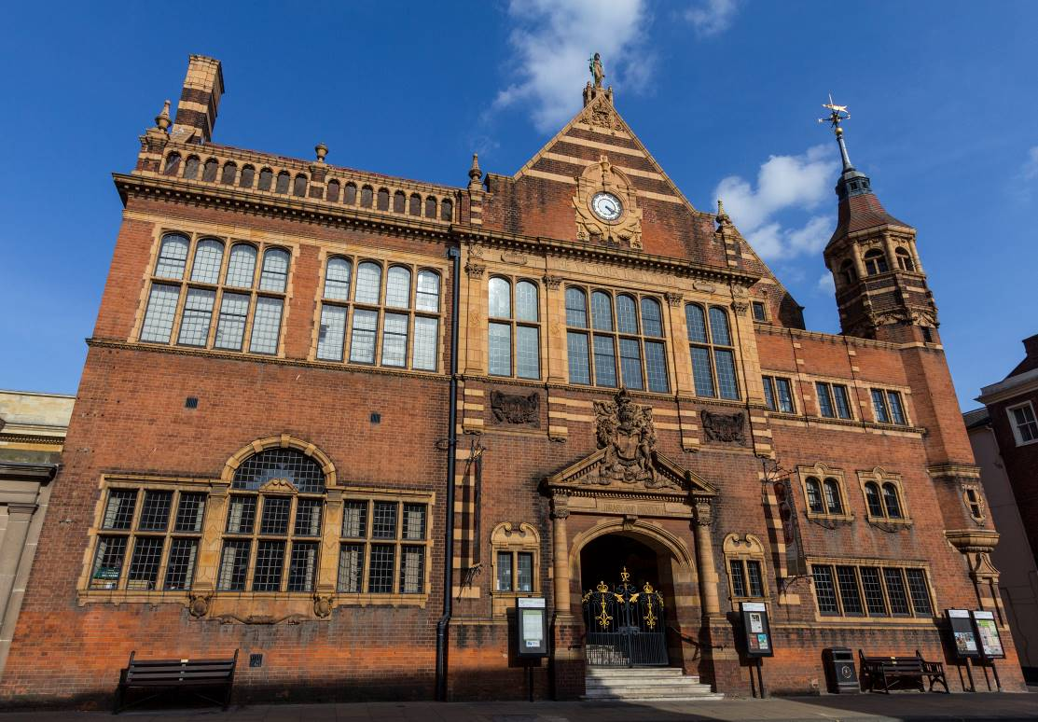
As well as public footfall, on the ground floor of the Art Gallery & Museum building (but not open to the public) is the main City Council offices.
We have recently significantly improved the retail offer at the Art Gallery & Museum and have an exciting programme of exhibitions opening in the next few years. We are looking for a Caterer that shares our aim to create a quality experience for all our visitors and encourages them to make repeat visits. We would like to work together in the future to plan improvements to further enhance the café space and ambience and have budget available for commissioning professional advice in this area.
The café is located on two sides of the first-floor balcony seating up to 36 people and is accessible from a main staircase and a lift from Taylors Lane. The walls of the café are used by the Art Gallery to provide a changing exhibition programme to complement the café and its atmosphere.
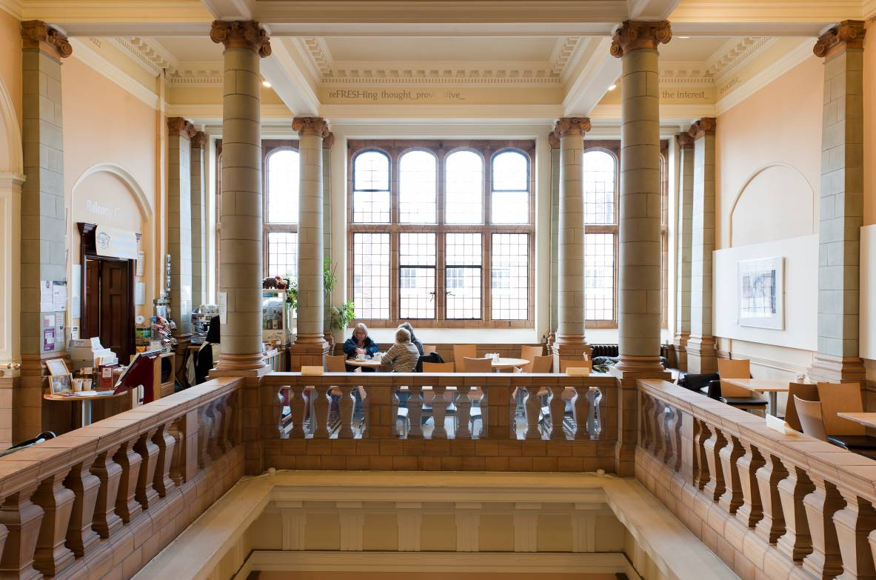

The Balcony Café is served by a kitchen measuring approximately 3.01m across and 5.2m in length, with a smaller storage area at the back measuring 1.57m by 1.53m. It is complete with oven, high level grill, dishwasher, chiller display cabinet, fridges, and freezers. The Café area itself has a till and tables and chairs available for use.

The café may also be used outside normal opening hours for additional catering functions provided any additional use is previously approved by the Museums General Manager and subject to payment of an additional fee.
The concession will be subject to a Licence Agreement for a period of three years, with an option to break after one year.

Interested parties are invited to submit proposals for the operation of the Balcony Café for the 3 years of the concession in the first instance. The proposal also needs to include an offer for the licence fee, the preferred offer is a percentage of gross turnover.

The Caterer should provide ideas for running the catering concession, including type of food and drink to be provided (the range of food and drinks provided will be agreed with the Art Gallery & Museum but please note fried food such as chips will not be permitted), opening times, staffing, ideas for additional functions or services to improve the visitor facilities and an indication of prices. We are also looking for details of experience and how the venue may be promoted.
The Council does not undertake to accept the highest or any offer received, and the additional information requested will be considered as part of the Caterer’s submission.
We are looking to reopen the Balcony Café in June, once the current restrictions relating to Covid-19 are lifted. At this point the long-anticipated Titanic exhibition will be on display (opening 17th May) which should work well to re-attract footfall.
Please send your offer form, trade and bank references, and completed caterers questionnaire to the Museums Audiences Manager at the Art Gallery and Museum, Foregate Street, Worcester WR1 1DT by 4pm on Monday 7th June, 2021. Interviews will be held at the Art Gallery & Museum on Thursday 17th June and you will be notified as soon as possible.

Further information may be obtained from:
Museums Audiences Manager
Worcester City Art Gallery & Museum
Email: Helen.Large@worcester.gov.uk

Principle terms for a Licence for the catering concession at
the Balcony Café, Worcester City Art Gallery & Museum

- For the purpose of this concession, the Caterer will have the use of the café and exclusive use of the adjoining kitchen, together with the use of toilets in common with the Museum

2. The public opening hours of the Art Gallery and Museum are:

Monday  Tuesday  Wednesday  Thursday  Friday  Saturday | 10.30 - 4.30  10.30 - 4.30  10.30 - 4.30  10.30 - 4.30  10.30 - 4.30  10.30 – 4.30 | These days may include some  Bank Holidays when the building  may be open to the public

Opening during Museum hours is essential; there will also be opportunities outside of these hours at special events and functions. The Council shall always have the right to cancel the provision of these facilities on any day or days on giving 48 hours previous notice but assures the caterer that any such cancellation will only happen in exceptional circumstances. This will also include some Bank Holidays, when the building may be closed. If opening hours for the building change, this will be done in discussion with the licence holder.
3. The Caterer will be required to liaise with the Museum staff in promoting the venue and providing a catering service which compliments and supports exhibitions and events at the Art Gallery and Museum.
4. There is a small amount of equipment that is the property of the Council and shall be made available for use by the Caterer, should it be required. The Council will be responsible for the maintenance and repair of the equipment.
5. The Caterer will be responsible for the payment of all gas and electricity charges for the concession. The telephone rental and charges will be the responsibility of the caterer.
6. The Caterer will be responsible for maintaining all areas in a clean tidy and hygienic condition and will be required to comply with all relevant legislation relating to Health and Safety and food Hygiene, with a Food Hygiene rating of 4 or higher. A no smoking policy operates in this building.
7. The Caterer will be required to obtain and retain a minimum public liability insurance of £5 million for the catering concession
8. The Caterer will arrange for the daily removal of all waste and refuse from the premises to an approved area and will meet the cost of the collection of waste at least once a week.
9. The concession may be terminated by the Council should the Caterer fail to maintain a satisfactory standard of service and customer care or in the event of the Caterer being in breach of the terms of the agreement for the catering concession.
10. The Caterer will be required to complete a formal agreement with the Council for the catering concession which will include other terms as may be considered appropriate by the Council’s Deputy Director of Governance
11. There may be an option for the Caterer to renew the concession at the end of the three year term at a revised licence fee and amendments to the conditions considered appropriate by the Museums General Manager and subject to the Caterer having observed and performed the various conditions set out in the agreement.

CATERING CONCESSION AT WORCESTER CITY ART GALLERY & MUSEUM

TRADE REFERENCES
1)
Name:........................................................................................

Address:.....................................................................................

...................................................................................................

...................................................................................................

...................................................................................................

2)
Name:........................................................................................

Address:.....................................................................................

...................................................................................................

...................................................................................................

...................................................................................................

BANK REFERENCE

Name:........................................................................................

Address:.....................................................................................

...................................................................................................

...................................................................................................

...................................................................................................

CATERING CONCESSION AT WORCESTER CITY ART GALLERY & MUSEUM

OFFER FORM

I/WE ......................................................................................................................
of ......................................................................................................................
hereby submit an offer for the catering concession at the Balcony Cafe at the Art Gallery and Museum, Worcester as follows:
Year 1 %.................(figures) (words) per annum.
Year 2 %.................(figures) (words) per annum.
Year 3 %.................(figures) (words) per annum.

I/WE understand that Worcester City Council is not bound to accept the highest or any offer received.

Signed:...............................................................................................

Date:...................................................................................................

Address:.............................................................................................

...........................................................................................................

...........................................................................................................

Signed:.............................................................................................

Date:.................................................................................................

Address:...........................................................................................

.........................................................................................................

.........................................................................................................

